REPORT OF ACTION TAKEN UNDER LICENCE  BADGER LICENCES  For licences issued under the Protection of Badgers Act 1992 |  |  | 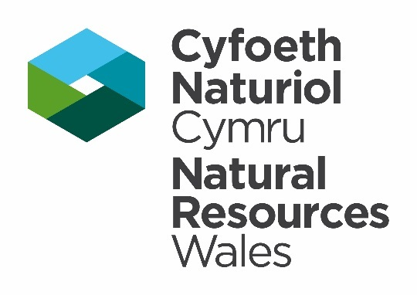
Species Permitting Team, Natural Resources Wales, Maes-y-Ffynnon, Penrhosgarnedd, Bangor, Gwynedd, LL57 2DW.
Telephone: 03000 653 000
Email: specieslicence@naturalresourceswales.gov.uk
GUIDANCE NOTES Please read the following notes carefully before completing the table overleaf in BLOCK CAPITALS or type. This form may be downloaded from our website, completed and emailed to us.

- It is a condition (Condition 11) of your licence that you provide Natural Resources Wales with a report detailing action taken under the licence. This report must be completed, even if no action is taken, and must be returned to Natural Resources Wales (details above) within 4 weeks after the licence expiry date.
- Failure to complete and submit this form is a breach of your licence. It is an offence under Regulation 10(8) to breach a licence condition.
- The report is used to provide summary information to the Department for Environment, Food and Rural Affairs (Defra) and the European Commission regarding the number and type of licences issued and the actual work carried out under the licence. The data collected from licence reports might also be used for scientific monitoring purposes and be shared with the Local Planning Authority. If you have concerns about the use of the information you are providing, please contact us using the details shown at the top of this form.
- The personal information on this licence report may be kept and used by Natural Resources Wales in accordance with the General Data Protection Regulations and in line with the provisions of the licence under which the collection of these biodiversity records was authorised.
- This report form must only be completed by the Lead Licensee, Licensed Nominated Ecologist or Licensed Accredited Agent(s) as listed on the licence.
LICENCE DETAILS
Lead Licensee Name:
Licensed Nominated Ecologist Name:
Site Address:
Licence Reference Number:
Licence Issue Date:
Licence Expiry Date:
Was the licence implemented? |  | Yes ☐ |  | No ☐
- If you have not implemented your licence the licence is declared a nil return and no further information will be required within this report. Please sign and date the declaration.

- If the licence was implemented, please complete all questions.

YOUR LOCAL BIOLOGICAL RECORDS CENTRE
Natural Resources Wales advises all biological data associated with this licence is shared with your Local Biological Records Centre. Please contact your local records centre directly via the website www.lrcwales.org.uk.

Please confirm the records associated with this licence have been sent to the local records centre by ticking this box. ☐

NATIONAL RECORDING SCHEMES
Natural Resources Wales advises all biological data associated with this licence is submitted to a national recording scheme in addition to it being shared with your Local Biological Records Centre.

Please confirm whether data has been uploaded to a national recording scheme and that data is also accessible to NRW and LRC’s ☐

PART 1: Interference With a Badger Sett

1a.

Purpose of licence | Number of Setts Disturbed | Number of Setts Destroyed | Methods Used | Dates of Activity | Location (including 8 figure Grid Reference)
Choose an item.
Choose an item.
Choose an item.
Choose an item.
Choose an item.
Choose an item.
Choose an item.

Part 2: Kill, Take, Possess, Mark or sell Badgers for Scientific, Education or Conservation purposes.

If your licence was issued for scientific, educational or conservation purposes, please complete 2a and 2b below:

2a.

Purpose of licence | Number taken | Number killed | Number possessed | Number marked | Number sold | Adult or Cub | Dates | Period Held | How and where disposed of
Choose an item. |  |  |  |  |  | Choose an item.
Choose an item. |  |  |  |  |  | Choose an item.
Choose an item. |  |  |  |  |  | Choose an item.
Choose an item. |  |  |  |  |  | Choose an item.
Choose an item. |  |  |  |  |  | Choose an item.
Choose an item. |  |  |  |  |  | Choose an item.
Choose an item. |  |  |  |  |  | Choose an item.

2b.Please provide details of any papers you intend to publish in connection with the work undertaken under this licence:

Part 3: Photographs
All licence reports must submit photographs. This is stated in Condition 11 of all licences. Please attach photographs as an additional document.

Confirm photographs are attached in an additional document. |  | Yes ☐ | No ☐
State the document title/reference.
Provide a description of what the photographs are indicating/demonstrating/verifying.
When submitting large file attachments, please request a ShareFile link from the Permitting Team - specieslicence@naturalresourceswales.gov.uk. Please state the licence number and site address in the email.

PART 4: Declaration
You must read this section before making the declaration and sending your form to us.

To the best of my knowledge, the data is reliable and was collected with the necessary permissions.

NRW have my permission to store, copy, use, release and publish the biodiversity records I have supplied, including my name as part of the record, in line with the provisions of the licence under which the collection of these biodiversity records was authorised.

Signature of the individual who completed this report. |  | Date
For electronic submissions please insert an electronic signature above or place an x in the box opposite to confirm agreement with the declarations above. |  |  | ☐
Full name in BLOCK LETTERS

