October 2022

Ysgol Rhos Helyg, Ceredigion on the trail of the Wales Coast Path
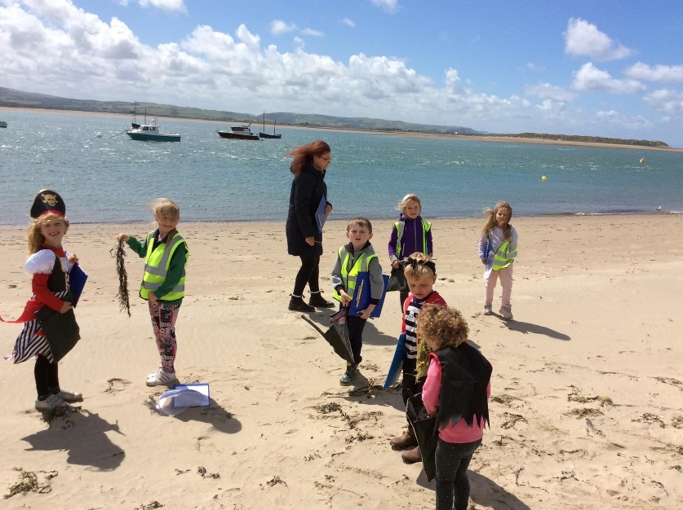
The 870-mile-long Wales Coast Path which stretches along the entire length of the Welsh coastline offers a plethora of learning opportunities. With the Path celebrating its 10th birthday in 2022, we launched a suite of education resources to support groups to learn on, about and for the path and offered education groups that had attended our ‘Wales Coast Path – your route to coastal learning’ webinars a travel bursary of up to £200 to help towards the cost of visiting the path. One setting which took up the offer was Ysgol Rhos Helyg, near Tregaron, Ceredigion. Teacher Sioned Owen shares their experiences.

“Our theme during the Summer term was Pirates and Cardigan Bay. We studied the Ceredigion coast and located villages and towns on a map. The children also wanted to learn about the Lowland Hundred legend and we also learnt about the history of pirates and Black Bart. We decided to take a trip to Aberdovey beach as a work highlight.”

“On the beach, the pupils completed a scavenger hunt and we also used our senses and recorded what we saw, heard etc.

This hands-on experience of the coast was very valuable for the pupils. They were able to discuss what is seen at the beach and describe the experience of being there. Seeing the Aberdovey bell also brought the Lowland Hundred story to life for them. Back in the classroom, the children planned and wrote a pirate story. The ability to use their experience of the coast was very helpful in describing and imagining the lives of their characters. We also used the scavenger hunt objects for Mathematics work.

The children really enjoyed the visit. It is so important to provide first-hand experiences for them to bring the learning alive. The bus trip was a great way to notice the landscape and study different geographical features. A great culmination to our theme!
Looking for learning resources, information or data? Please contact:
education@naturalresourceswales.gov.uk or go to https://naturalresources.wales/learning
Alternative format; large print or another language, please contact:
enquiries@naturalresourceswales.gov.uk
0300 065 3000

