October 2022

“A conker fight – what’s that?” What’s happened to the playground game?
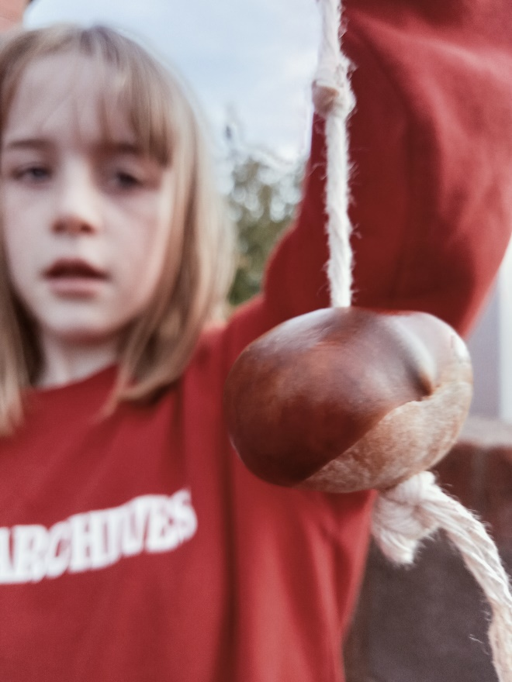
Small and shiny, conkers are one of the natural jewels of autumn’s bounty. Once much sought after, primed for battle by being baked in ovens or soaked in vinegar before being put on string ready for the playground, we ask why, one of the oldest games around, seems to have fallen by the wayside?
Health and safety concerns that kids must wear goggles to play conkers? According to the HSE this is an absolute health and safety myth. A well-meaning head teacher decided children should wear safety goggles to play conkers. Subsequently some schools appear to have banned conkers on ‘health & safety’ grounds or made learners wear googles. The HSE state that the risk from playing conkers is incredibly low and is not of concern and if learners deliberately hit each other over the head with conkers, it’s a discipline issue, not health and safety.
Are we parents to blame? With day-to-day lives being much more hectic do we just have less time to supervise our children baking conkers in ovens and drilling holes into them? Or has the advent of the tablet and computer game meant that learners are less likely to steal themselves away from the screen and into the woods? Why would learners want to speed time foraging damp ground for a prize conker when they can switch on their device and instantly engage in digital play?
We call on you to dig deep and unearth your inner child. Drag your learners out, take them in search of a horse chestnut in your local park or street and encourage them to go on an autumnal exploration. Can they find the winning conker that will conker all? The personification of autumn, why not hold a conker tournament at your setting? If you need to bring your learners up to speed on the rules of the game, the National Trust have a useful guide.

Looking for learning resources, information or data? Please contact:
education@naturalresourceswales.gov.uk or go to https://naturalresources.wales/learning
Alternative format; large print or another language, please contact:
enquiries@naturalresourceswales.gov.uk
0300 065 3000

