September 2022

Looking to a natural future: Flintshire looks to grow its outdoor learning provision
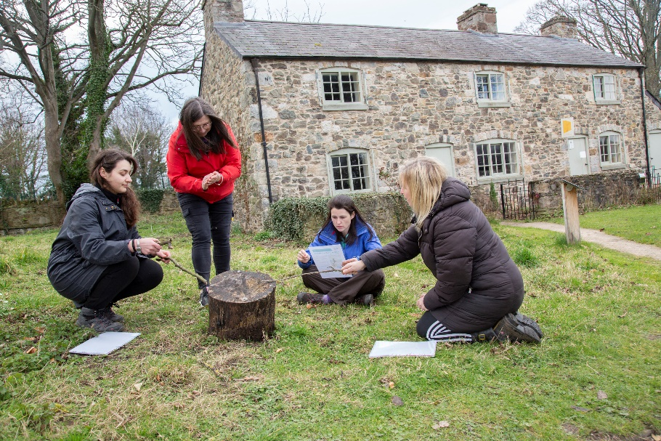
In the 2021/2022 academic year, Flintshire County Council added a target to their annual business plan to increase outdoor learning across the county. Research by Flintshire’s Education team suggested that Foundation Phase pupils spent around 30% of their time outdoors whilst Key Stage 2 learners only spent about 10% of their time on outdoor activities. The council partnered with Natural Resources Wales and other providers to increase the amount of outdoor learning that was delivered by schools in the county, especially amongst 7 to 11 year olds. Jane Borthwick, Learning Adviser - School Improvement Primary at Flintshire County Council shares the lessons learnt and looks to increase outdoor learning provision even further as the county embraces the Curriculum for Wales.

“We felt that outdoor learning was integral to the new curriculum and something that as a Local Authority we should support and promote. We knew there was very good practice in forest school and that schools offered outdoor learning during focused days and sessions. Our aim was to equip more practitioners across more schools to be able to provide learning in the outdoors as a natural part of the curriculum.

We canvassed schools in the autumn of 2021 to see what the current level of engagement with outdoor learning was and identified interested practitioners. We then worked with partners such as Natural Resources Wales to offer a range of outdoor learning training days. Outdoor learning resources were shared to help practitioners plan for the new curriculum and schools were encouraged to see the natural environment as a resource to encourage a sense of cynefin.

- 77 practitioners from 66 settings attended training days on planning outdoor learning for the Curriculum for Wales with Natural Resources Wales based around ‘Shipwrecked’ and from “Crime scene to courtroom” scenarios.
- 18 practitioners from 9 second language primary schools worked on an outdoor learning project promoting the use of incidental Welsh with Natural Resources Wales in partnership with the Flintshire Welsh team and the Urdd’s Outdoor Activity Service.
- 16 small schools have completed outdoor learning projects with North Wales Outdoor Learning with a total of 24 practitioners gaining their certificate as an outdoor learning practitioner.
- 41 practitioners from 25 settings attended ‘Planning in the moment’ outdoor training for the Foundation Phase with provider, Anna Ephgrave.
- Work was undertaken on linking pupils to their local environment and to the wider Flintshire area. 11 school settings have taken a total of 550 pupils into the Area of Outstanding Natural Beauty on the Clwydian Hills to work on sustainable land use with the AONB staff.
- We’ve incorporated outdoor learning as an agenda item on each Deputy and Assistant Heads network meeting to give attendees the opportunity to share experiences and ideas.

Feedback on all these sessions and projects has been excellent and practitioners have shared that they feel more confident in taking learning out into the natural environment. Settings have reported an average increase of 15% in the amount of time spent participating in outdoor learning – equivalent to a 1.5 session a week increase on the previous year which is fantastic. We are on a learning journey and are keen to carry on and do more which will hopefully ensure that the amount of time Flintshire schools invest in outdoor learning will continue to increase, helping to establish pro-environmental behaviours in our pupils from a young age. Working with partners, we will look to offer more training opportunities and outdoor learning projects linked to the Curriculum for Wales during 2022/23.”

Looking for learning resources, information or data? Please contact:
education@naturalresourceswales.gov.uk or go to https://naturalresources.wales/learning
Alternative format; large print or another language, please contact:
enquiries@naturalresourceswales.gov.uk
0300 065 3000

