August 2022

Nature tots: childminding with nature
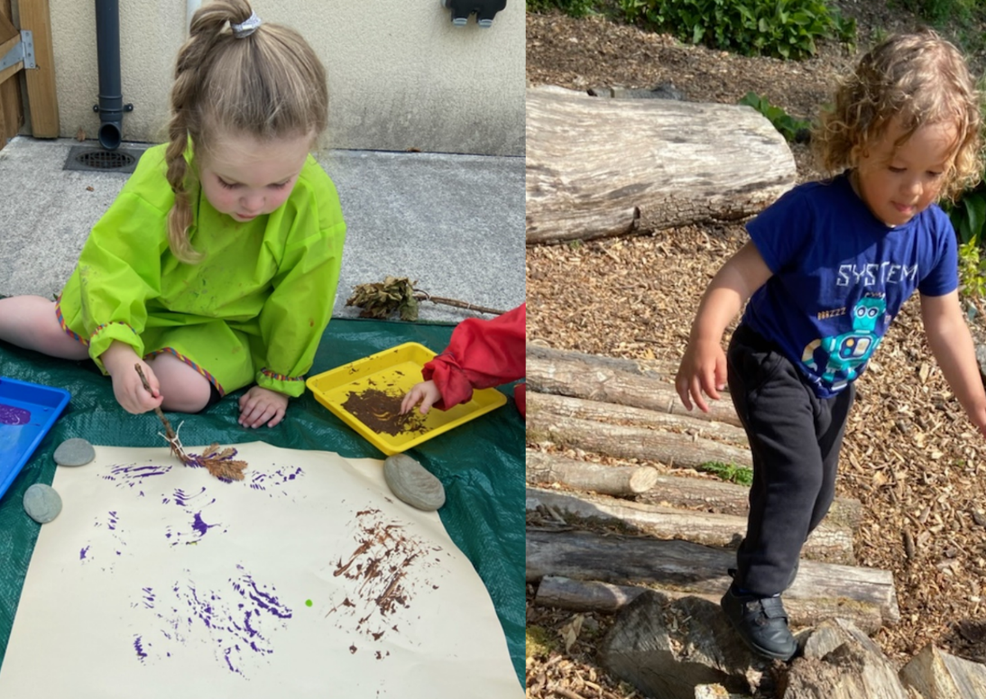

Creating time and space for fun, active learning in the natural environment for the children in her care comes as second nature to Carmarthenshire childminder Kelly Still. Having previously worked as a primary school teacher, Kelly has worked as a childminder for 8 years. A PACEY member, she currently works with 6 families with children between the ages of 9 months and 6 years under her care. Working with multiple children of varying age ranges means that careful planning is essential to be able to access the wider natural environment safely whilst providing opportunities for exploration, investigation and open-ended play.

In this case study Kelly share’s her tips and tricks and Joanne Morris, Regional Manager of PACEY Cymru, shares the organisation’s thoughts on the importance of outdoor learning.

Living and working in beautiful Carmarthenshire, there are many parks and natural areas Kelly can access with her learners. Before venturing out to anywhere new with the children in her care, she will go on a pre-visit to check the lay of the land and complete a risk assessment to check the area is suitable. How does Kelly manage outdoor learning whilst working with a multiple age range of children? All the tools of the trade Kelly explained: “I use a double buggy with a seat attachment which allows me to accommodate three small children. For older, more confident walkers, I use a walking safety web (particularly in areas where there may be water). I also use personalised Hi-Vis vests in crowded areas for that extra element of safety.” Less is best. Taking a rucksack with a few small containers, some ‘wildlife detective’ spotter sheets and magnifying glasses means Kelly is always prepared for interesting finds. Wet-wipes and a bottle of water are also ‘must-have’ items!

The children in her care love visiting the beach, feeding the ducks at the local reservoir, going on woodland walks and playing in nearby parks and fields. Kelly believes that exploring in nature is beneficial in developing a sense of belonging and community and that these experiences help the children to develop confidence, self-esteem, communication skills and pro-environmental behaviour. “Exploring the natural environment further afield provides children with an extra element of excitement, awe, and wonder. It can also provide un-planned learning opportunities that come from being always on the look-out for minibeasts and wildlife such as interesting logs to climb on and puddles to jump in!”

Making the most of what she has available, Kelly has also developed her garden to maximise outdoor learning opportunities. In September 2021 Kelly began creating a garden area specifically for the use of childminding children at her home. This has been ever changing, being added to with different apparatus and equipment and has quickly become a firm favourite with the children. “The children and I have planted a wildflower mix this Spring to attract the bees and butterflies to our garden as well as some lovely sunflowers. We have collected pieces of driftwood which have become a new favourite home for our woodlice! In addition to this we have a range of birdfeeders which the squirrels and birds both adore, we see them on a daily basis!” Outdoor provision back at her base is often based on the seasons and follows on from local visits in the natural environment, for example, the children enjoyed playing with a rock pool tuff tray after a visit to the local beach!

Growing children’s interest, Kelly has installed a number of raised beds where she grows potatoes, broccoli, peas and lettuce which the children love picking! “This year we have added a greenhouse to produce a variety of fruits, vegetables and herbs which are then used in the meals provided to the children.”

Kelly believes it very important to provide all-year-round access to the outdoors and has a variety of resources and equipment to ensure children can be outdoors in all weathers. “I use charity shops and car boot sales along with some great budget supermarkets to access wet weather gear and wellies as spares (incase items are forgotten). This ensures that there are no barriers to getting outside and everybody can enjoy the natural environment.” Small and large tarpaulins are used both on the ground and as overhead canopies to provide protection from the sun and rain.

Kelly works closely with parents and carers and shares daily photographs of activities to keep them informed of what their children have been doing. The feedback she receives on their outdoor learning experiences is always positive. “As a self-employed childminder, this is highly rewarding for me and continues to inspire me to provide high-quality early education provision.” Kelly feels that spending time outdoors has a definite positive impact on the behaviour and well-being of children in her care. “As soon as I mention that it’s time for outdoor play to the children, they all shout in delight! This is an absolute pleasure to hear as it confirms that these experiences are enhancing their spiritual and emotional development.”

Spending time learning in, about and for the natural environment is something that is actively encouraged by PACEY Cymru. Joanne Morris, Regional Manager explains further. “In Wales, the importance of children having access to opportunities to spend time outdoors and in nature is well recognised and valued. There is a strong emphasis on being outdoors within the Curriculum for Wales. Connecting with nature provides a wealth of opportunities to inspire exploration and support children’s, learning and development, physical health, and mental well-being. As Kelly has done, childminders can make use of a range of local natural spaces to support this, whether this is in their own garden or through outings to the local park, woods, or beach.”

To support with ideas and inspiration PACEY Cymru have teamed up with Natural Resources Wales to develop some resources, including two CEY smart courses focussed on mathematical development and the natural world, and a course to support with introducing pro-environmental behaviours in the early years. Find out more about this in PACEY Cymru’s Blog: supporting outdoor learning and explore the curriculum changes in this article, Spotlight on the new curriculum for Wales.

Learning in, learning about and learning for the natural environment

Looking for learning resources, information or data? Please contact:
education@naturalresourceswales.gov.uk or go to https://naturalresources.wales/learning
Alternative format; large print or another language, please contact:
enquiries@naturalresourceswales.gov.uk
0300 065 3000

