Teacher describes flytipping investigation during Wales Outdoor Learning Week as “one of the most memorable, AMAZING weeks in my teaching career!”
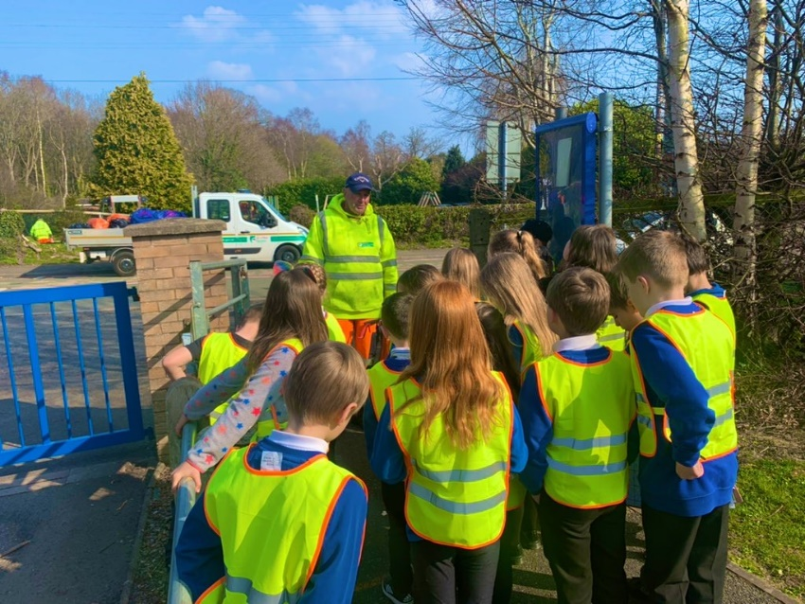
Following training from Natural Resources Wales (NRW), Megan Hughes, a Year 3 teacher at Ysgol Sychdyn, Flintshire decided to put the 'From Crime to Courtroom: Enviro crime’ training to life.

Using the Mantle Approach, pupils received a phone call from a concerned local who had witnessed someone fly-tipping. Having gone out to investigate, pupils found some black bin bags had been dumped in their school grounds! Assuming the role of NRW Environment Officers, pupils used a range of numeracy skills to explain the location of the bin bags, record the weather and wind conditions and the distance of the bags to the school’s watercourse. The pH and ammonia levels of the water were tested to see whether the water had been impacted by the “hazardous materials” and pupils explored how long the waste would take to break down if left in-situ. After investigating the contents of the bags and sorting them in a tally chart, pupils were assigned different roles to bring the case to court. Finally, pupils reflected on their learning by linking each activity to the Four Core Purposes and by recording a ‘Fly tipping Vlog!’

Throughout the week, there was an abundance of learning experiences that really brought the experience to life for pupils. “By fluke, we met a member of Flintshire Street Scene who was collecting litter outside our school. He explained the impacts of fly-tipping and just how big this problem is. We emailed an Environment Officer based in New Zealand, who explained the processes he undertakes in preventing fly-tipping and offered some wonderful advice to us – ‘We have a job to make sure that we leave the planet in better condition than it was when we were born.’ Finally, a Police Officer from Flintshire visited our classroom to collect evidence ready to take the suspect to court!”

Megan explained, “To have people within varying roles help bring this to life (often with little time in advance to plan!) is something that I am truly grateful for. The children absolutely loved the work we did on 'From Crime to Courtroom' and there has been a real buzz in our school as a result. The feedback I received from pupils, staff and parents was invaluable. The week was truly a highlight of my teaching career and I am incredibly proud of my Year 3 class of superstars. A huge thank you to Ffion and team from Natural Resources Wales for sharing the 'From Case to Courtroom' training with me and for the wealth of teaching materials available online that helped me to plan such a fantastic week. I would recommend this to anyone.”

Looking for learning resources, information or data? Please contact:
education@naturalresourceswales.gov.uk or go to https://naturalresources.wales/learning
Alternative format; large print or another language, please contact:
enquiries@naturalresourceswales.gov.uk
0300 065 3000

