14th April /  14th Ebrill | 2022
Llwybr / Trail | Ar agor Open /  Ar Gau Closed | Manylion / Details
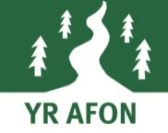 | Ar agor/ Open
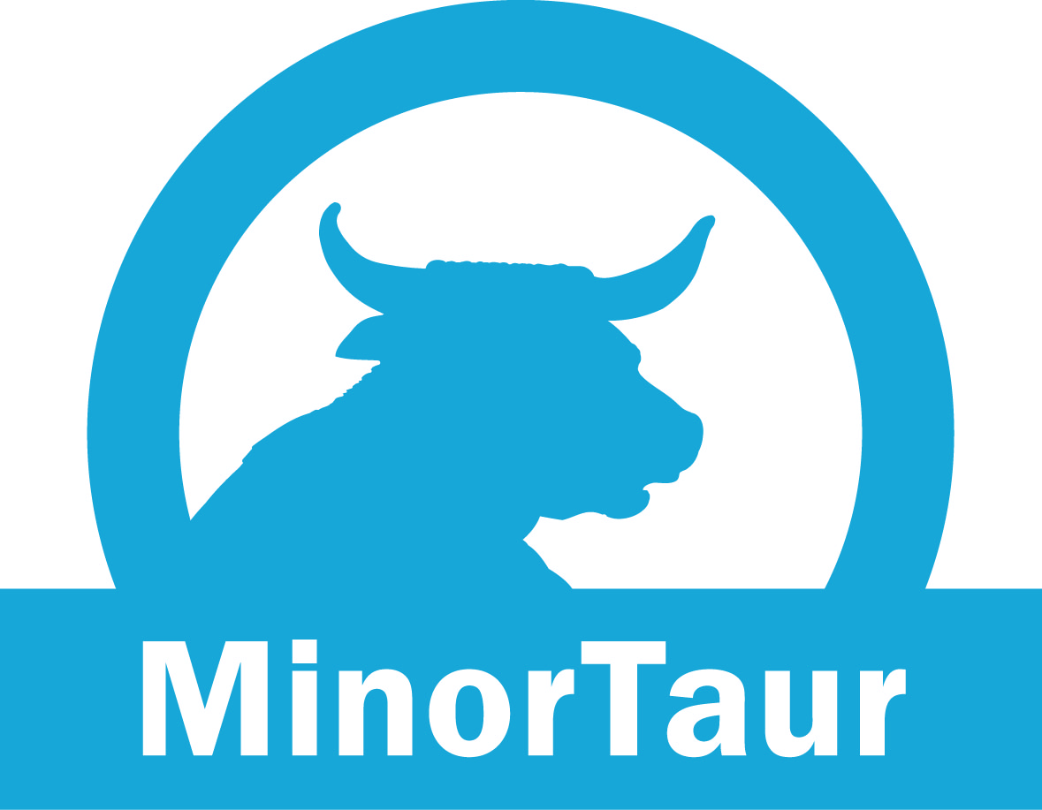 | Ar agor/ Open
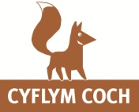 | Ar agor/ Open
 | Ar agor/ Open
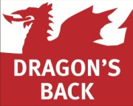 | Gwyriad/Diversion | - Mae Llwybr Morticia ar gau oherwydd gwaith cwympo coed; dilynwch y gwyriad.  - Morticia is closed due to tree felling operations. Please follow the diversion.
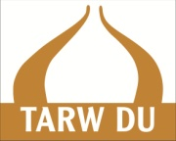 | Gwyriad/Diversion | - Llwybr yn agored gyda gwyriad. Mae ‘Pins & Needles’, ‘Flightpath’ ac ‘R74’ wedi cau oherwydd difrod storm a chan fod coed wedi syrthio. Dilynwch y gwyriad.  - Trail open with a diversion. ‘Pins & Needles’, ‘Flightpath’ & ‘R74’ are closed due to storm damage and windblown trees. Please follow the diversion.
 | Ar agor/ Open
 | Gwyriad/Diversion | - Mae Llwybr Morticia ar gau oherwydd gwaith cwympo coed; dilynwch y gwyriad.  - Morticia is closed due to tree felling operations. Please follow the diversion.
Ardal Sgiliau a Pharc Beiciau  Y Ffowndri  Skills Area &  Bike Park | Ar agor/ Open

