
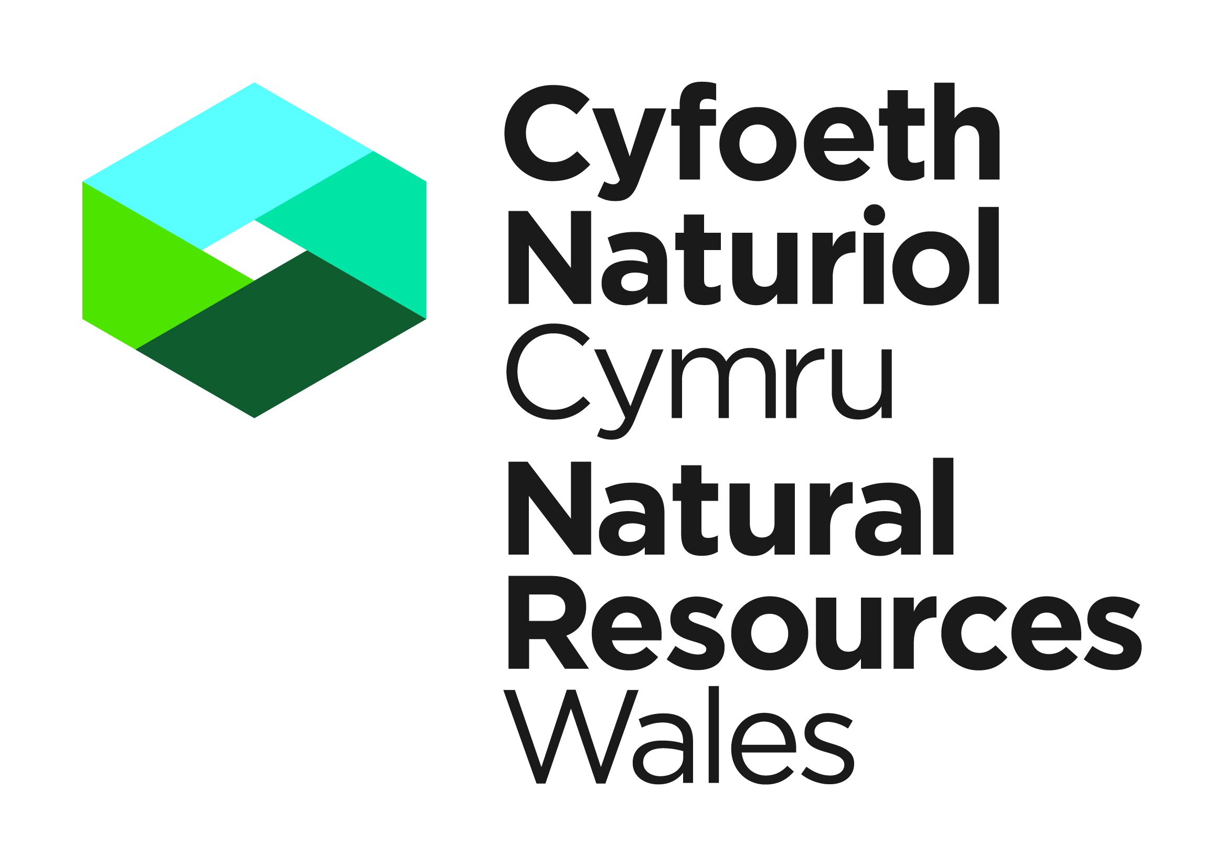

APPLICATION FOR A LICENCE TO SELL, EXCHANGE OR OFFER FOR SALE OR EXCHANGE
ANY WILD ANIMAL (OR DERIVATIVE)

WILDLIFE AND COUNTRYSIDE ACT 1981 (AS AMENDED) (WCA) OR THE CONSERVATION
OF HABITATS AND SPECIES REGULATIONS 2017

Information for completion of an application form:

- All applicants should complete part A.
- Applicants should complete part B if they are working on species listed under Annexe IV of the Council Directive 92/43/EEC on the Conservation of natural habitats and of wild fauna and flora.
3. Applicants should complete part C if they are applying for species listed only under Schedule
Schedule 5 & 6 of the Wildlife & Countryside Act 1981 (as amended).
- All applicants should complete part D to F.
- All applicants are advised to read the supporting notes on the back of this form.

PART A: Personal Details and Experience

All questions relate to the person who will be the named licensee if a licence is granted under the Wildlife and Countryside Act 1981 (as amended) or the Conservation of Habitats and Species Regulations 2017. That person should complete and sign this form. Please complete in BLOCK CAPITALS (* delete as applicable)

- (a) Name of applicant

Title (Mr/Mrs/Miss/Ms/Dr) |  | Forename(s) |  | Surname

(b) Address to where the licence is to be sent
 | Town
 | County |  |  | Postcode
Tel number (incl. national dialling code)
Mobile number
Email address
2. Please give details of qualifications and experience in this field for all those who are requested to be covered by this licence, including boat operators and accredited agents.
3. Have you ever been convicted of a wildlife offence? YES/NO*

If ‘YES’, give details.

4. Have you held any type of relevant licence within the last 2 years? YES/NO*

If ‘YES’ Please give your last licence number, details of the licensing authority who issued that licence and a copy of the licence.

Please complete Question 5 if you have not held a licence for similar activities and species in the last two years.

5. If you have not previously held any type of relevant licence please provide the name and address of two referees who are familiar with your work. They should be able to comment on your experience of working with the relevant species (or similar species) and your ability to use the methods and equipment you have proposed. Ideally your referees should have held a similar licence within the last two years.

e-mail | e-mail

PART B: Application Details for European Protected Species

Only complete this part if you are applying for a licence dealing with species listed on Annexe IV of the Council Directive 92/43/EEC on the Conservation of natural habitats and of wild fauna and flora.

- Please complete the table below to show all licensable actions that the project will involve. Please read the notes at the bottom of this page. Use photocopies of this page if there is insufficient space on one sheet

Species | Activity (1) | Number (2) | Sex (2) | Age or life stage (2) | Description (2) | Possession licence reference (3) | Location (4)

NOTES
 | 1. | Activity. List all the activities you wish to carry out. Start a new line if it helps to distinguish between different activities at different places. Choose from:  Offer for sale & sell  Offer for exchange & exchange
 | 2 | Number, sex and age. This only needs to be completed where applicable. Where appropriate give the number of specimens or derivatives involved, if alive or dead and/or a description of the material. Please indicate in the description column if the species is alive or dead. If it is a derivative please describe the material.
 | 3 | Possession Licence reference. Please give the details of the licence under which you already possess this material. If you do not currently hold such a licence then please contact the licensing body.
 | 4 | Location. Please state specific sites and counties where the specimen or derivatives will be held.

7. If your application concerns a European Protected Species, please confirm how your proposed actions will not be detrimental to the maintenance of the population of the species concerned at a favourable conservation status within their natural range. Please also provide a statement as to why there is no satisfactory alternative to the issue of this licence to permit the proposed activities.

PART C: Application Details for species protected under the Wildlife & Countryside Act 1981 (as amended)

Only complete this part if you are applying for a licence dealing with species listed on Schedule 5 & 6 of the Wildlife & Countryside Act 1981

- Please complete the table below to show all licensable actions that the project will involve. Please read the note at the bottom of this page. Use photocopies of this page if there is insufficient space on one sheet

Species | Activity (1) | Number (3) | Sex (2) | Age or life stage (2) | Description (2) | Possession licence reference (3) | Location (4)

NOTES
 | 1. | Activity. List all the activities you wish to carry out. Start a new line if it helps to distinguish between different activities at different places. Choose from:  Offer for sale & sell  Offer for exchange & exchange
 | 2 | Number, sex and age. This only needs to be completed where applicable. Where appropriate give the number of specimens or derivatives involved, if alive or dead and/or a description of the material. Please indicate in the description column if the species is alive or dead. If it is a derivative please describe the material.
 | 3 | Possession Licence reference. Please give the details of the licence under which you already possess this material. If you do not currently hold such a licence then please contact the licensing body.
 | 4 | Location. Please state specific sites and counties where the specimen or derivatives will be held.

PART D: Sale or exchange of protected material.

9. Complete only if you are involved in the sale or exchange of material. The other party or parties involved in sale or exchange must also ensure they are appropriately covered.

a. If you are able please provide the details of the other parties involved in the sale or exchange.

b. Indicate if, and under what appendix, any of the species you wish to sell/exchange are listed under CITES.

c. Please indicate your Article 10 certificate number.

Note: if the species are listed under CITES, a licence will only be issued if appropriate permissions have also been granted under CITES regulations. On receipt of this application we will liaise with the CITES regulatory body over the details of this application.

PART E: Details of actions for all parts B & C above

10 The licensing body may wish to monitor the actions you carry out. Are you willing to allow the staff access to the site for this purpose?

YES/NO*

11. Please place an x the main purpose behind the licensable elements of your work.

Science or education
Conserving wild animals or introducing them to particular areas
Animal or plant sales under 16 (4) of the Wildlife and Countryside Act 1981 (as amended).
This option can only be used when species are only listed under part C above.

12. Please explain the need to carry out the proposed actions and the objective of your activities.

Any further information you wish to provide in support of your application should be appended on additional sheets. For example, if the work forms part of a scientific project, it will help your application if you provide a description of the methods with a detailed timescale. However, all questions on the application form must be completed in full.

PART F: Declaration

WARNING: NRW can modify or revoke any licence that may be issued but this will not be done without good reason. Any licence that is issued is likely to be revoked immediately if it is discovered that false or incorrect information had been provided on this form or any enclosures that resulted in the issue of a licence.

Applicants should note that it is an offence under Section 17 of the WCA and under regulation 59 of the Conservation of Habitats and Species Regulations 2017 to knowingly or recklessly provide false information in order to obtain a licence.

I understand that failure to comply with any conditions included on any licence granted in respect of this application may constitute an offence
I have read the notes for guidance on the back of this form
I declare that the particulars given in this application and accompanying documents are correct to the best of my knowledge and belief, and I apply for a licence in accordance with these particulars
If a licence is granted I agree to send to NRW a written report of the licensed activities within four weeks of the expiry of the licence

Signature |  | Date
For electronic applications please insert an electronic signature above or place an x in the box opposite to confirm agreement with the declarations above.

NAME IN BLOCK LETTERS

Thank you for completing this form. Please return it to NRW at the address below:-

Species PermittingTeam, Natural Resources Wales, Maes y Ffynnon, Penrhosgarnedd,
Bangor, LL57 2DW or e-mail your completed form to specieslicence@naturalresourceswales.gov.uk
Tel. 03000653000

NOTES FOR GUIDANCE (Please read the following notes carefully before completing this form).

- This is an application to sell, exchange or offer for sale or exchange any wild animal (or derivative) included in either the Wildlife and Countryside Act 1981 (as amended) or the Conservation of Habitats and Species Regulations 2017, depending on the species involved, to allow people to carry out activities which would otherwise be illegal. Applicants must be able to demonstrate that they have a suitable amount of expertise to achieve the objectives of the proposed work.

- All questions in this application form must be completed in full unless otherwise stated: failure to provide adequate information will delay the processing of your application. Any further information you wish to provide should be appended on additional sheets. We aim to process applications within 30 working days of receipt of all the information requested. We cannot guarantee an earlier response.

- Information from applications and licences is required to provide summary information on the number of licences issued, the purpose of the licence and which species are covered. None of these summary statistics include personal information about licensees. The information may also be used for conservation purposes and shared with other organisations.

- As sale or exchange of protected species involves two parties both must ensure they are appropriately licensed for their activities. It is however recognised that on receipt of a licence for sale an individual may not be able to identify who the prospective purchaser will be. Consequently a licence issued for sale or exchange can be transferred to a second party as part of the sale/exchange, provided certain conditions are met:

A letter of transfer (available from the relevant licensing body) is signed by the original licence holder and the new holder.

A copy of the transfer letter is retained by both the original and new holder, with the original being sent to the licensing authority.

That the new holder complies with all conditions of the licence.

That the sale/exchange is for the purpose specified under the licence e.g. for the purpose of science or education.

If you experience any problems filling in this form, or wish to dispose of the material instead of selling it please contact Natural Resources Wales.

- The information provided by you will be processed by Natural Resources Wales in line with the GDPRs Data Protection Principles. This will to enable us to process your application; to monitor compliance with any permit conditions; to process renewals, and to maintain the relevant public register.

We will process the information you provide in connection with the following:
- Consultation with third parties who are relevant and responsible for responding to consultation requests from NRW to enable us to process your application
- Carrying out statistical analysis, research and development on environmental issues
- Providing public register information for enquiries
- Preventing and investigating possible breaches of environmental law and taking any resulting action
- Responding to requests for information under the Freedom of Information Act 2000 and the Environmental Information Regulations 2004
We would also like to send you details about other topics we think may be of interest to you such as NRW news; services relating to environmental matters; asking for your feedback on our service; and more useful information.
If you consent to receiving further information from us, please tick the following box to confirm

Yes, I would like to receive additional information from NRW relating to environmental matters □
Please note we may pass the information on to our agents or representatives to carry this out for us

If you have any further queries or concerns, please contact dataprotection@naturalresourceswales.gov.uk. For further information on the processing of your personal details please see our Privacy Notice page

- Any information included in this application which the applicant considers to be in confidence for commercial or industrial reasons or to be the applicant’s intellectual property must be clearly marked as such.

- Applicants should note that a licence from NRW does not grant access or power of entry onto any land.

In this document “Natural Resources Wales” means the Natural Resources Body for Wales established by article 3 of the Natural Resources Body for Wales (Establishment) Order 2012. The Natural Resources Body for Wales (Functions) Order 2013 transferred the relevant functions of the Countryside Council for Wales, and functions of the Environment Agency and the Forestry Commission in Wales to the Natural Resources Body for Wales.

