RFB 01  Report by licensee of action taken under licence to kill or take (non-Piscivorous) birds  Wildlife and Countryside Act 1981 (as amended) |  | 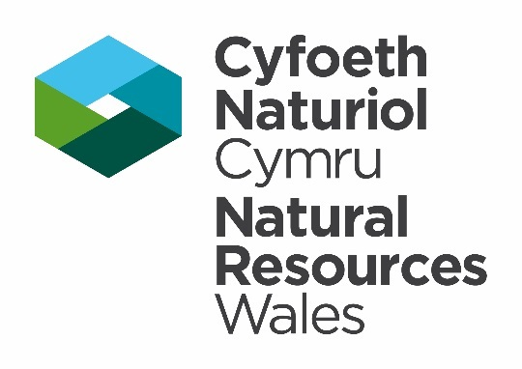
Please return this form to –
By Email: specieslicence@naturalresourceswales.gov.uk
By post - Species Permitting Team, Natural Resources Wales, Maes-y-Ffynnon, Penrhosgarnedd, Bangor, Gwynedd, LL57 2DW.
Telephone: 03000 653 000

GUIDANCE NOTES Please read the following notes carefully before completing the table overleaf in BLOCK CAPITALS or type. This form may be downloaded from our website, completed and emailed to us.

- It is a condition of your licence that you provide Natural Resources Wales with a report detailing action taken under the licence. This report must be completed, even if no action is taken, and must be returned to Natural Resources Wales (details above) within 4 weeks of the licence expiry date.
- Failure to complete and submit this form is a breach of your licence and may result in any future applications being refused. It is an offence under Section 17 of the Wildlife and Countryside Act 1981 (as amended) to breach a licence condition.
- The report is used to provide summary information to the Welsh Government and the European Commission regarding the number and type of licences issued and the actual work carried out under the licence. The data collected from licence reports might also be used for scientific monitoring purposes and help inform future applications. If you have concerns about the use of the information you are providing, please contact us using the details shown at the top of this form.
Licence Reference Number:
Licence Issue Date:
Licence Expiry Date:
Name of Licence Holder:
Contact Email Address:
Contact Telephone Number:
Address of Licensed Site:
Description of site (e.g. Farm land, park, warehouse etc.)

Section 1) Report of Action Taken – This section must be completed for all licences.

Please describe the activities completed under this licence.
Report on the actions as described in your licence application. An example is provided.

Date | Details of method used (trapping, shooting, netting, poisoned bait, destruction etc.) | Species | Killed, trapped and released, nest destroyed or egg destroyed | Number
28/11/19 | Shooting | Carrion Crow | Killed | 5

If you have NOT carried out any work under the licence please place an x in the box opposite. | ☐

Additional information or comments – Please use this space to add any additional information you wish to report and/or reference any documents which have been submitted in support of this report.

Photographs

Please confirm if any photographs are attached in an additional document. |  | Yes ☐ | No ☐
State the document title/reference.

Section 3) Declaration
You must read this section before making the declaration and sending your form to us.

To the best of my knowledge, the data is reliable and was collected with the necessary permissions.

By submitting this report, I confirm that NRW have my permission to store, copy, use, release and publish the biodiversity records I have supplied. in line with the provisions of the licence under which the collection of these biodiversity records was authorised.

The data protection notice – Permitting and Licensing can be found at https://naturalresources.wales/footer-links/privacy-notice/?lang=en

Signature of the Licence Holder |  | Date
For electronic submissions please insert an electronic signature above or place an x in the box opposite to confirm agreement with the declarations above. |  |  | ☐
Full name in BLOCK LETTERS

