Photographic evidence for Glastir Woodland Creation

October 2015

1. Forward
This note providences guidance for photographic evidence which can be used for Glastir Woodland Creation scheme verification on certain new planting sites:-

- Biodiversity Habitats: Geo-referenced photographs are needed to demonstrate that the site is not a Biodiversity Action Plan priority habitat or a traditional orchard. Outside the main growing season from mid-May to September, photos are likely to be misleading and can fail to show important species so extra care must be taken – (see Annex 1).
- Biodiversity Species
Fungi: Geo-referenced photographs to demonstrate a site is improved grassland (grassland fungi grow in unimproved grassland)
Arable Plants: Geo-referenced photographs to demonstrate a site does not have arable plants.

2. What is required?
- Photographs must be numbered, in colour and in focus. The photo needs to identify the feature concerned to do this sufficient photographs are needed to demonstrate that the site is not a priority habitat or deep peat.
The recommendation for photographs of habitats is to take a photo of two square meters. Take one oblique and one ‘straight down’ photograph for each different vegetation type.
- The images should be supplied as a JPEG file.
- The photo must be clearly labelled and dated: − Digital images should be saved with an appropriate file name ‘Customer Reference Number’ photo number date taken’ i.e. A0008130 ‘_NO1_Aug 2015’;
- Identify the location from which the photographs were taken.
- Geo-reference the photographs, which establishes a feature’s location in terms of map projections
- Coordinate systems. This is done by assigning latitude and longitude or another geographical reference to the image. This is most commonly carried out using a camera with a built-in GPS receiver, a function that is available on many smartphones, using a downloadable app.

E.g. The Grid Free app was downloaded free of charge. This provides a grid reference of the location of the phone and can then be used to rename or tag your photo in your smartphone

Mark the number of the photographs on an accompanying Ordnance Survey map, note the direction in which it was taken and provide an 8 figure grid reference (example provided below).

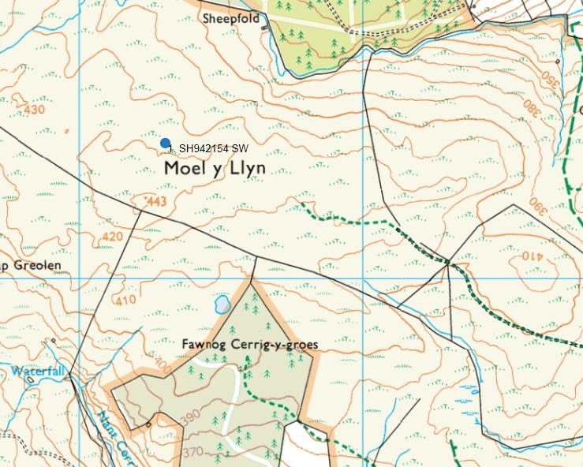

Map showing geo-referenced GWC scheme in word document

Insert the photographs into a Microsoft Word document and anotate using text boxes and arrows. Send this document with photographic evidence with the GWC plan, consultation responses and maps to NRW verifiers.

In this example woodland planners would use this photo as evidence that this is not the priority habitat - Upland Flushes, Fens and Swamp.

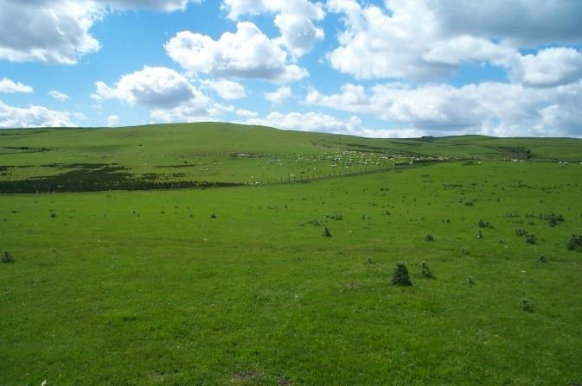

Grazed by sheep

Ground not waterlogged

Rye grass is dominant

Annex 1. Habitats

Analysis of the EOI submitted in 2016 have shown six priority habitats:

Lowland dry acid grass

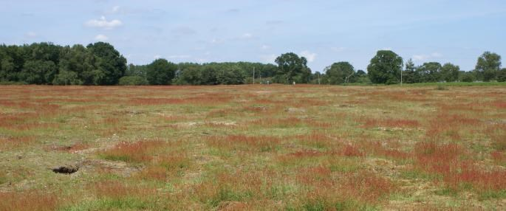

These are grasslands and grassy stands with bracken on well-drained acid soils in the lowlands (normally below c. 300m). They consist mostly of short, grazed swards of grasses growing with small herbs and mosses. They occur commonly in mosaics with neutral and basic grasslands (including agriculturally improved grasslands), scrub and rock outcrops.

Lowland Heath
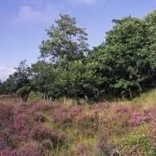

They are generally found on poor, acidic soils, in relatively wet areas with a mild temperature below about 300 metres altitude. Characterised by a mosaic of wet, damp and dry habitats characterised by flowering dwarf shrubs:
- Heathers – including bell heather
- Ling and gorse
- Scots pine and birch

Upland Heath

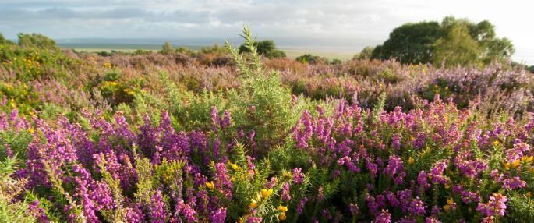

Heathland vegetation occurs widely on mineral soils and thin peats (<0.5 m deep), which generally occurs in area’s above 300m
Throughout the uplands and moorlands of the UK Upland heath in ‘favourable condition’ is typically dominated by:-
- A range of dwarf shrubs such as heather, bilberry, crowberry, bell heather - In south and west Wales, western gorse.

Purple moor grass & rush pasture

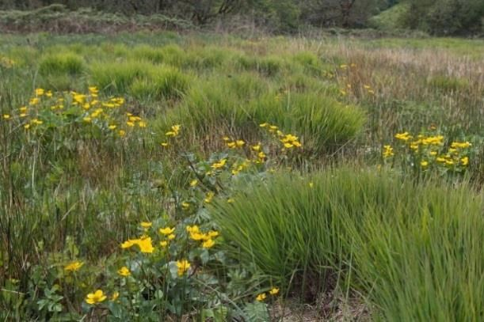

Purple moor grass and rush pastures occur on poorly drained, usually acidic soils in lowland areas of high rainfall in Western Europe. Their vegetation, which has a distinct character, consists of various species-rich types of fen meadow and rush pasture.

Lowland fens and reedbeds

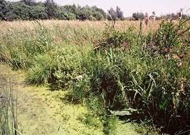

The Lowland fens priority habitat encompasses a very wide range of wetlands including soligenous and topogenous sedge and rush mires, stands of tall herb dominated vegetation and swamps dominated by tall sedges, grasses or herbs.

Reedbeds are early successional wetlands dominated by stands of the common reed, where the water table is at or above ground level for most of the year. They tend to incorporate areas of open water and ditches and small areas of more diverse fen, wet grassland and carr woodland may be associated with them.

Upland Flushes, Fens and Swamp

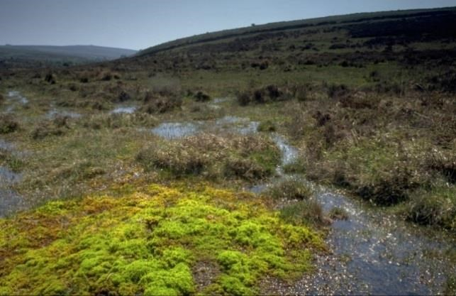

Upland flushes, fens and swamps are defined as peat or mineral-based terrestrial wetlands in upland situations. The soil is generally waterlogged with water table close or on the surface. It includes soils with more than 50cm deep peat. Varied habitat species but generally dominated by sedges and their allies, rushes grasses and occasionally wetland herbs, typically including:
- Molinia
- Phragmites
- Sphagnum spp
- Meadowsweet

